Classification Model: Multinomial Logistic Regression

Objective of the Classification Model
Q2 Classification: To build classification model that analyse impact level of global fuel price to countries fuel price changes by quarter.
The objective of this classification model is to classify the impact level of global fuel price changes on countries' fuel price changes by quarter. The target variable used in this model is impact_level, which consists of three classes: Low Impact, Medium Impact, and High Impact.
Multinomial Logistic Regression was selected because the classification problem has more than two outcome categories. Unlike binary Logistic Regression, which is used for two-class classification problems, Multinomial Logistic Regression can handle multi-class classification problems.
In this model, the predictors used are quarter, country, fuel_type, and crude_pct_change. These variables are used to examine whether quarterly crude oil price movements and country-level fuel information can classify the level of impact on country fuel price changes.
# Load required libraries
library(dplyr)
library(caret)
library(nnet)
library(ggplot2)
library(pROC)
# Load training and testing datasets
train_df <- read.csv("train_df.csv")
test_df <- read.csv("test_df.csv")

# If R cannot find the files, use this instead:
# train_df <- read.csv(file.choose())
# test_df <- read.csv(file.choose())

Data Preparation for Multinomial Logistic Regression
# Remove extra spaces from the target variable
train_df$impact_level <- trimws(train_df$impact_level)
test_df$impact_level <- trimws(test_df$impact_level)

# Convert target variable into factor with fixed class order
train_df$impact_level <- factor(
train_df$impact_level,
levels = c("Low Impact", "Medium Impact", "High Impact")
)

test_df$impact_level <- factor(
test_df$impact_level,
levels = c("Low Impact", "Medium Impact", "High Impact")
)

# Check class distribution
cat("Training class distribution:\n")
print(table(train_df$impact_level))

cat("Testing class distribution:\n")
print(table(test_df$impact_level))
# Convert categorical predictors into factors
categorical_cols <- c("quarter", "country", "fuel_type")

for (col in categorical_cols) {
train_df[[col]] <- factor(train_df[[col]])
test_df[[col]] <- factor(test_df[[col]], levels = levels(train_df[[col]]))
}
# Scale numerical predictor using training data statistics
crude_mean <- mean(train_df$crude_pct_change, na.rm = TRUE)
crude_sd <- sd(train_df$crude_pct_change, na.rm = TRUE)

train_df$crude_pct_change_scaled <-
(train_df$crude_pct_change - crude_mean) / crude_sd

test_df$crude_pct_change_scaled <-
(test_df$crude_pct_change - crude_mean) / crude_sd
# Select variables used in the model
model_vars <- c(
"impact_level",
"quarter",
"country",
"fuel_type",
"crude_pct_change_scaled"
)

# Remove missing values from selected variables
train_model <- train_df %>%
select(all_of(model_vars)) %>%
na.omit()

test_model <- test_df %>%
select(all_of(model_vars)) %>%
na.omit()

# Check final number of observations used
cat("Training rows used:", nrow(train_model), "\n")
cat("Testing rows used:", nrow(test_model), "\n")
The variable impact_level was used as the target variable. The predictors selected were quarter, country, fuel_type, and crude_pct_change_scaled. The numerical variable crude_pct_change was scaled to improve model stability.

Building the Multinomial Logistic Regression Model
# Build Multinomial Logistic Regression model
set.seed(123)

multi_log_model <- multinom(
impact_level ~ quarter + country + fuel_type + crude_pct_change_scaled,
data = train_model,
maxit = 1000,
trace = FALSE
)

# Display model summary
summary(multi_log_model)

Model Prediction
# Predict class labels on the test data
pred_class <- predict(
multi_log_model,
newdata = test_model,
type = "class"
)

pred_class <- factor(
pred_class,
levels = c("Low Impact", "Medium Impact", "High Impact")
)

# Predict class probabilities
pred_prob <- predict(
multi_log_model,
newdata = test_model,
type = "probs"
)

# View first few predicted probabilities
head(pred_prob)

Confusion Matrix and Classification Performance
# Confusion matrix
conf_matrix <- confusionMatrix(
pred_class,
test_model$impact_level
)

conf_matrix
The confusion matrix shows how many observations were correctly and incorrectly classified by the Multinomial Logistic Regression model. The diagonal values represent correct predictions, while the off-diagonal values represent misclassifications.

Visualisation of Confusion Matrix
# Convert confusion matrix into dataframe
cm_table <- as.data.frame(conf_matrix$table)

# Plot confusion matrix heatmap
ggplot(cm_table, aes(x = Reference, y = Prediction, fill = Freq)) +
geom_tile(color = "white") +
geom_text(aes(label = Freq), color = "white", size = 5, fontface = "bold") +
scale_fill_gradient(low = "lightblue", high = "darkblue") +
labs(
title = "Confusion Matrix Heatmap",
subtitle = "Multinomial Logistic Regression",
x = "Actual Impact Level",
y = "Predicted Impact Level",
fill = "Count"
) +
theme_minimal()

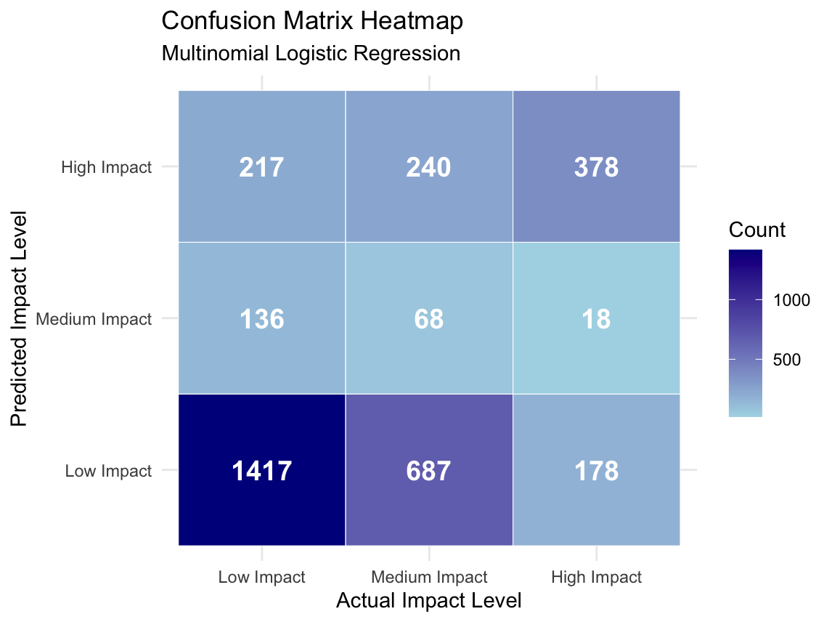

Accuracy, Precision, Recall and F1-Score
# Extract overall accuracy
accuracy <- conf_matrix$overall["Accuracy"]

# Extract per-class metrics
precision <- conf_matrix$byClass[, "Pos Pred Value"]
recall <- conf_matrix$byClass[, "Sensitivity"]

# Calculate F1-score
f1_score <- 2 * ((precision * recall) / (precision + recall))

# Create per-class performance table
metrics_df <- data.frame(
Class = rownames(conf_matrix$byClass),
Precision = round(precision, 4),
Recall = round(recall, 4),
F1_Score = round(f1_score, 4),
Balanced_Accuracy = round(conf_matrix$byClass[, "Balanced Accuracy"], 4)
)

metrics_df
# Calculate macro-average metrics
macro_precision <- mean(precision, na.rm = TRUE)
macro_recall <- mean(recall, na.rm = TRUE)
macro_f1 <- mean(f1_score, na.rm = TRUE)

# Create summary table
macro_metrics <- data.frame(
Metric = c("Accuracy", "Macro Precision", "Macro Recall", "Macro F1-score"),
Value = round(c(accuracy, macro_precision, macro_recall, macro_f1), 4)
)

macro_metrics
The accuracy shows the overall proportion of correctly classified observations. Precision shows how reliable the model is when it predicts a specific impact class. Recall shows how well the model identifies actual cases from each class. The F1-score provides a balanced measure between precision and recall.

Multiclass ROC and AUC
# Calculate multiclass AUC
multi_auc <- multiclass.roc(
response = test_model$impact_level,
predictor = pred_prob
)

multi_auc_value <- auc(multi_auc)

multi_auc_value
The multiclass AUC measures how well the model separates the three impact levels overall. A higher AUC value indicates stronger classification performance.

One-vs-All ROC Curves
# One-vs-All ROC curve for Low Impact
roc_low <- roc(
response = ifelse(test_model$impact_level == "Low Impact", 1, 0),
predictor = pred_prob[, "Low Impact"]
)

# One-vs-All ROC curve for Medium Impact
roc_medium <- roc(
response = ifelse(test_model$impact_level == "Medium Impact", 1, 0),
predictor = pred_prob[, "Medium Impact"]
)

# One-vs-All ROC curve for High Impact
roc_high <- roc(
response = ifelse(test_model$impact_level == "High Impact", 1, 0),
predictor = pred_prob[, "High Impact"]
)

# Plot ROC curves
plot(
roc_low,
col = "blue",
lwd = 2,
main = "One-vs-All ROC Curves for Multinomial Logistic Regression"
)

plot(
roc_medium,
col = "orange",
lwd = 2,
add = TRUE
)

plot(
roc_high,
col = "darkgreen",
lwd = 2,
add = TRUE
)

abline(a = 0, b = 1, lty = 2, col = "red")

legend(
"bottomright",
legend = c(
paste("Low Impact AUC =", round(auc(roc_low), 4)),
paste("Medium Impact AUC =", round(auc(roc_medium), 4)),
paste("High Impact AUC =", round(auc(roc_high), 4))
),
col = c("blue", "orange", "darkgreen"),
lwd = 2
)

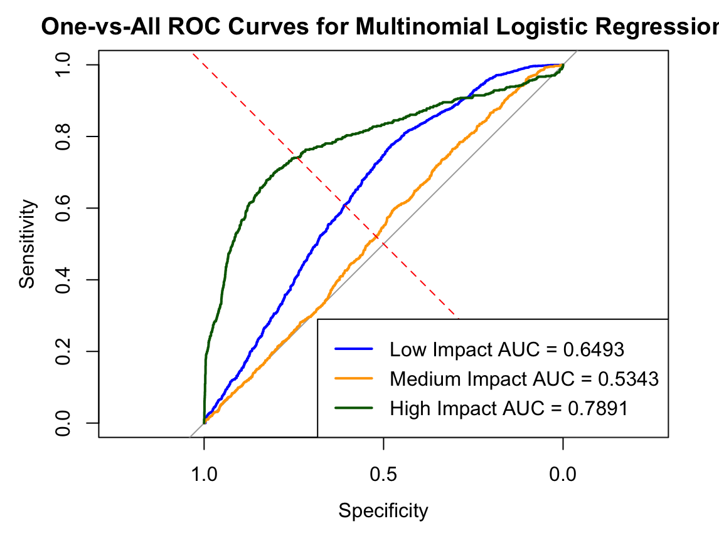

Model Results and Interpretation
Metric | Value
Accuracy | 55.80%
Macro Precision | 46.00%
Macro Recall | 50.91%
Macro F1-score | 44.92%
Multiclass AUC | 68.38%
Kappa | 0.2311
The Multinomial Logistic Regression model was developed to classify the impact level of global fuel price changes on country-level fuel price changes by quarter. The target variable used was impact_level, which consists of three categories: Low Impact, Medium Impact, and High Impact. The predictors used in the model were quarter, country, fuel_type, and crude_pct_change.
Based on the test dataset, the model achieved an overall accuracy of 55.8%. This means that the model correctly classified 55.8% of the observations. The No Information Rate was 53.01%, which represents the accuracy that could be achieved by always predicting the majority class. Since the model accuracy is only slightly higher than the No Information Rate, this indicates that the model provides some improvement over a simple majority-class prediction, but the improvement is limited.
The confusion matrix shows that the model performed best in classifying Low Impact observations. Out of the actual Low Impact cases, the model correctly classified 1,417 observations, giving a recall of 80.06% for this class. This suggests that the model is reasonably good at detecting lower-impact fuel price changes.
For High Impact, the model showed moderate performance. It correctly classified 378 High Impact observations, with a recall of 65.85%. However, the precision for High Impact was 45.27%, meaning that not all observations predicted as High Impact were actually High Impact cases.
The weakest performance was observed for Medium Impact. The model correctly classified only 68 Medium Impact observations, while many Medium Impact cases were misclassified as Low Impact or High Impact. The recall for Medium Impact was only 6.83%, showing that the model had difficulty identifying this category. This may suggest that Medium Impact observations are less clearly separated from the other two classes using the selected predictors.
The macro-average results further support this interpretation. The model achieved a Macro Precision of 46.00%, Macro Recall of 50.91%, and Macro F1-score of 44.92%. Although the overall accuracy was 55.8%, the low Macro F1-score shows that the model performance was not balanced across all three impact levels. In particular, the poor performance for Medium Impact reduced the overall class-balanced performance.
The model also achieved a Multiclass AUC of 0.6838, indicating a moderate ability to distinguish between Low Impact, Medium Impact, and High Impact classes. However, this value also suggests that the model still has room for improvement.
Overall, the Multinomial Logistic Regression model provides a useful baseline for the classification problem. It is able to identify Low Impact cases relatively well and shows moderate ability in detecting High Impact cases. However, it struggles to classify Medium Impact observations accurately. This indicates that the relationship between global crude oil price changes and country-level fuel price impact may be more complex than what a linear classification model can fully capture. Therefore, more flexible machine learning models such as Random Forest or XGBoost may be better suited to improve classification performance.

